ECT583 Final – Online Game Store

Rong Zhuang

# Summary

* 1. Credit Gateway

<http://ectweb2.cs.depaul.edu/ECTCreditGateway/>

Totally four gateway services are created, two for local and two for remote. And one for user registration and another for payment when placing order.

|  |  |  |  |
| --- | --- | --- | --- |
| **CreditAppId** | **CreditAppSharedKey** | **Local/Remote(Azure)** | **Usage** |
| 76 | D*QSQ*mHr* | Localhost | User Registration |
| 77 | $pO4sfN$s$ | Localhost | Place Order |
| 78 | HlbfORCa!t | Remote | User Registration |
| 79 | ithHz$dxTR | Remote | Place Order |

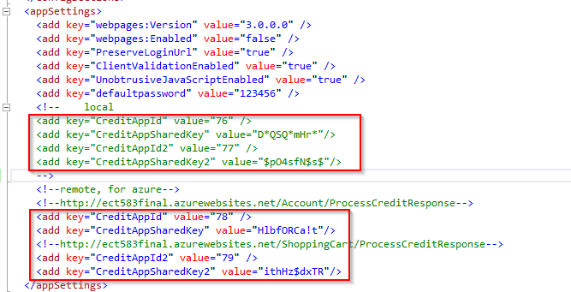

* 1. Roles

There are 3 different roles for this application, admin, advanced and regular.

* 1. Default User Account
* admin@gamestore.com / admin
* advanced@gamestore.com / advanced
* regular@gamestore.com / regular
  1. Technical Feature
* C#, ASP.NET MVC, WebAPI
* Azure Deployment
* Entity Framework (Code First)
* SQL Server for persistence
* ASP.Net Identity: User and Role, Admin Area
* Authentication and Authorization
* Cache: Output Caching, ASP.NET Cache
* Bootstrap, jQuery
  1. App in Azure

<http://ect583final.azurewebsites.net/>

# Pages

* 1. Home Page

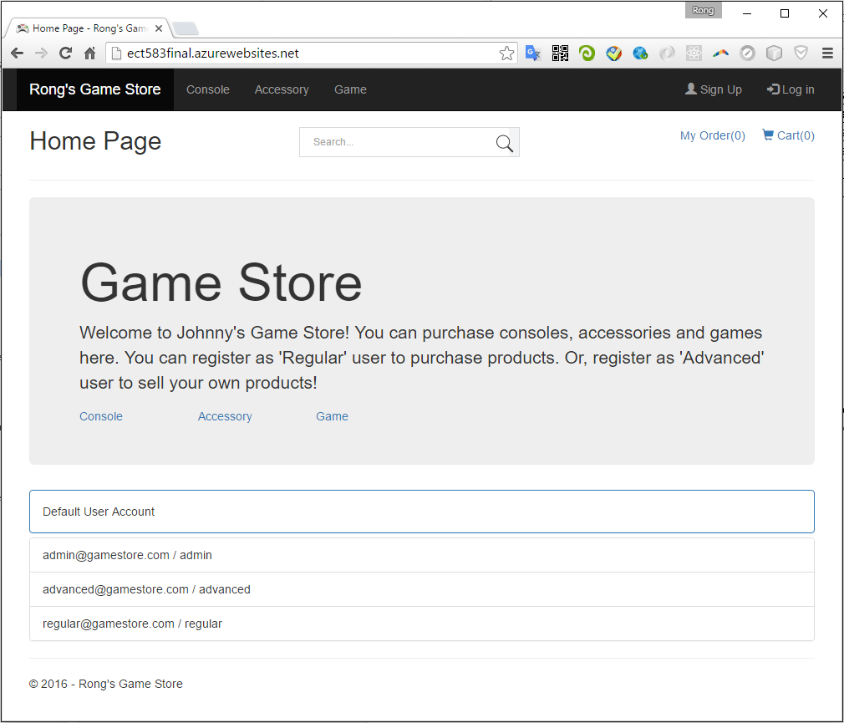

* 1. Consoles

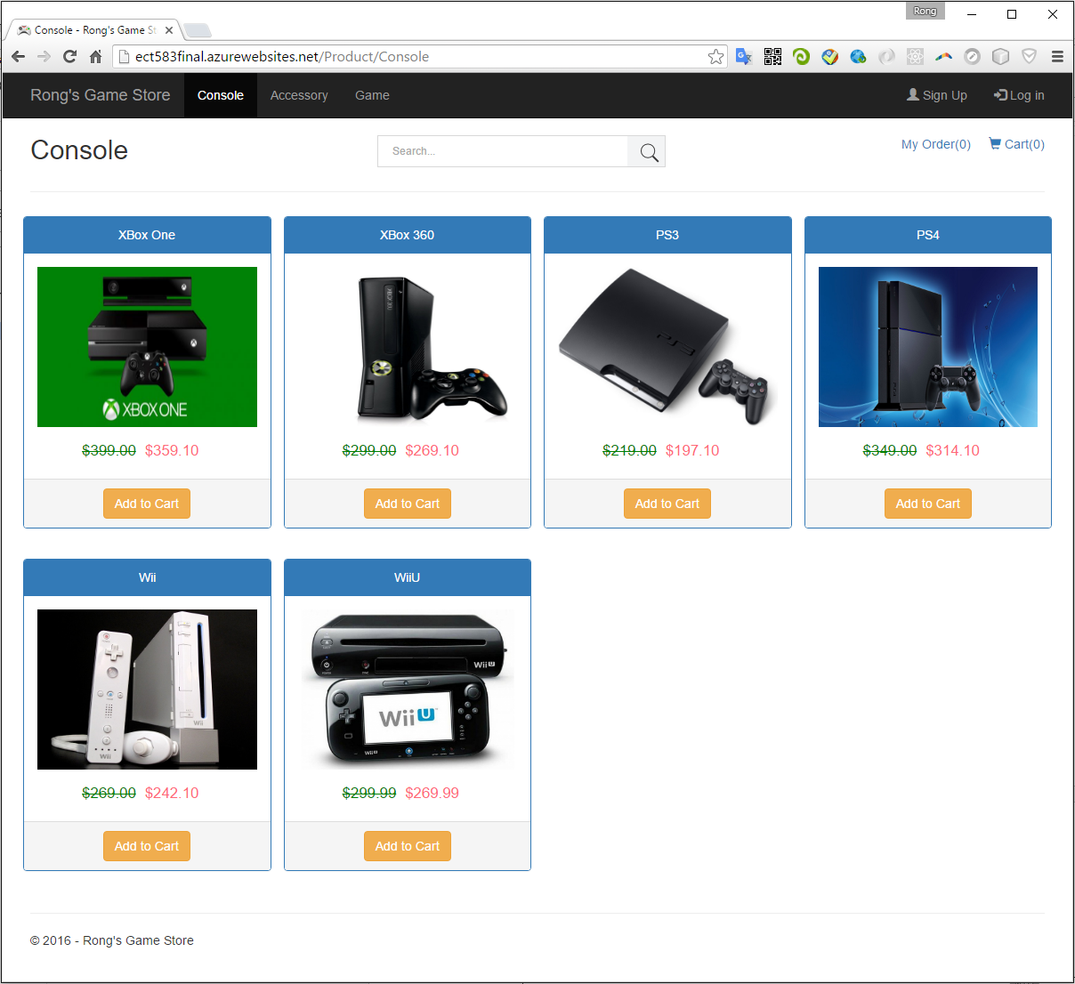

* 1. Accessories

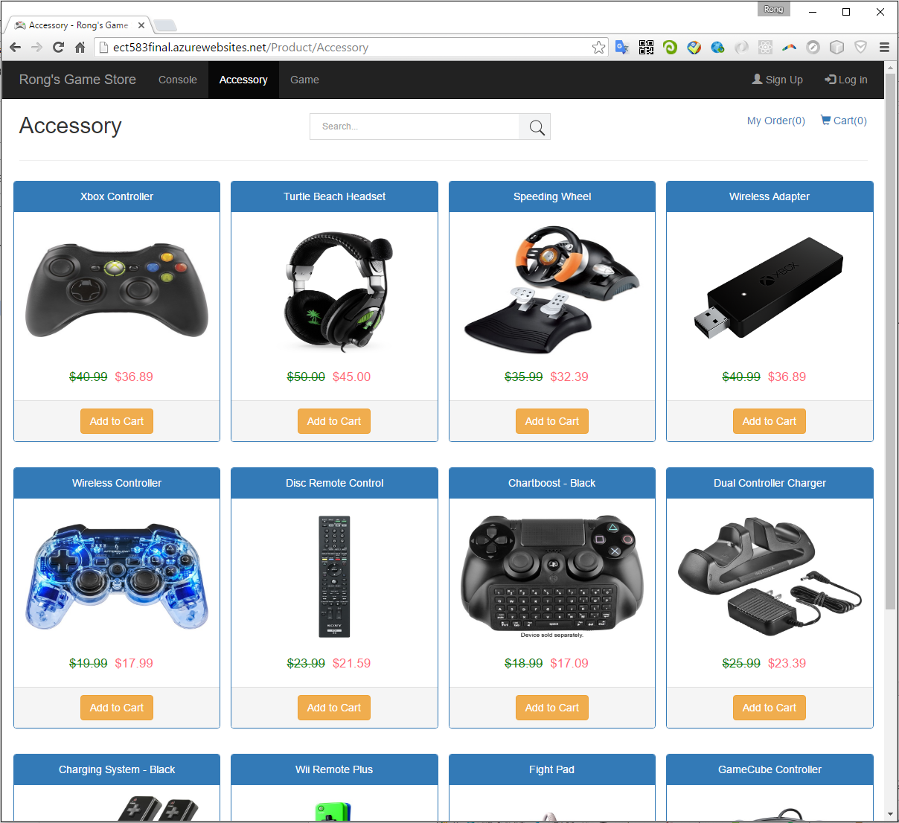

* 1. Games

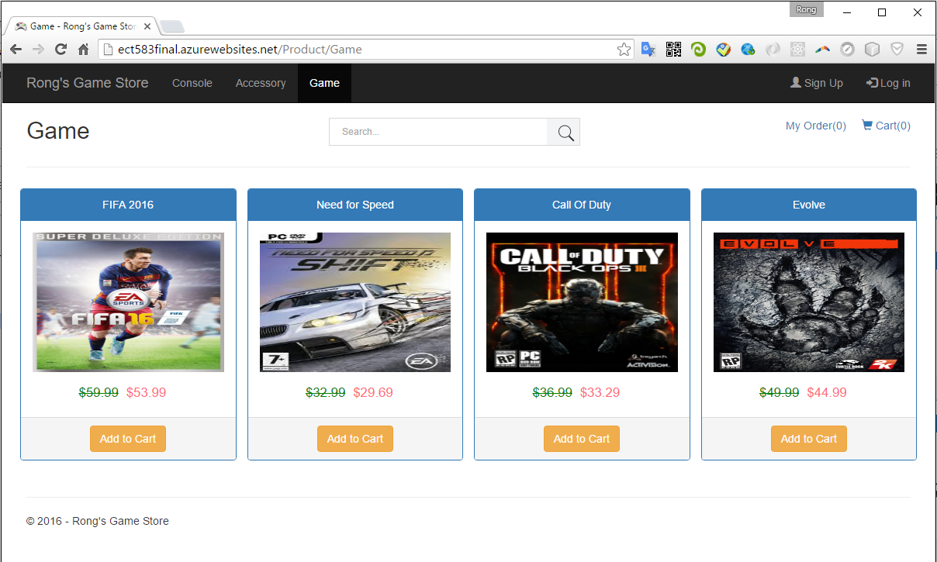

# General Functions

* 1. Search Products

1. You can search any product, including Console, Accessory and Game.

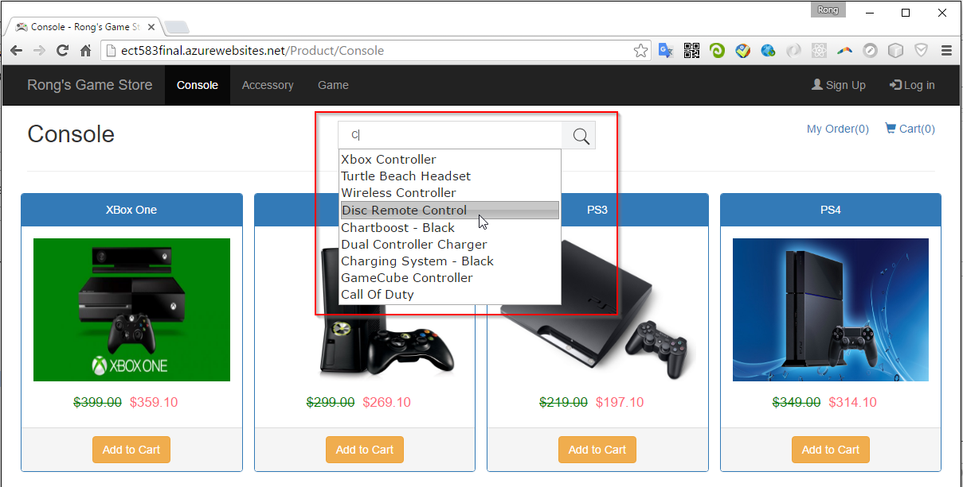

1. Auto complete is implemented.

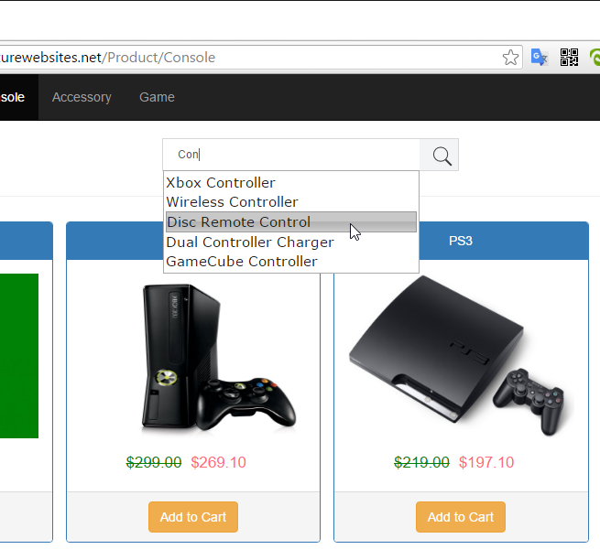

1. Search Results.

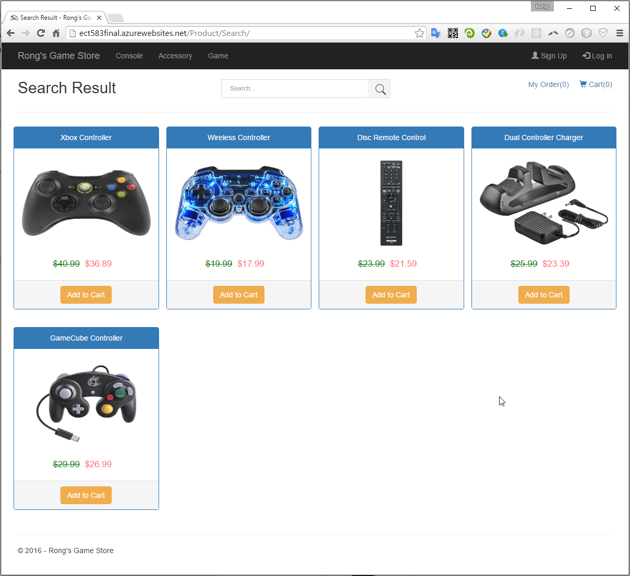

* 1. Register

You can choose Regular($49.99) or Advanced($99.99) membership.

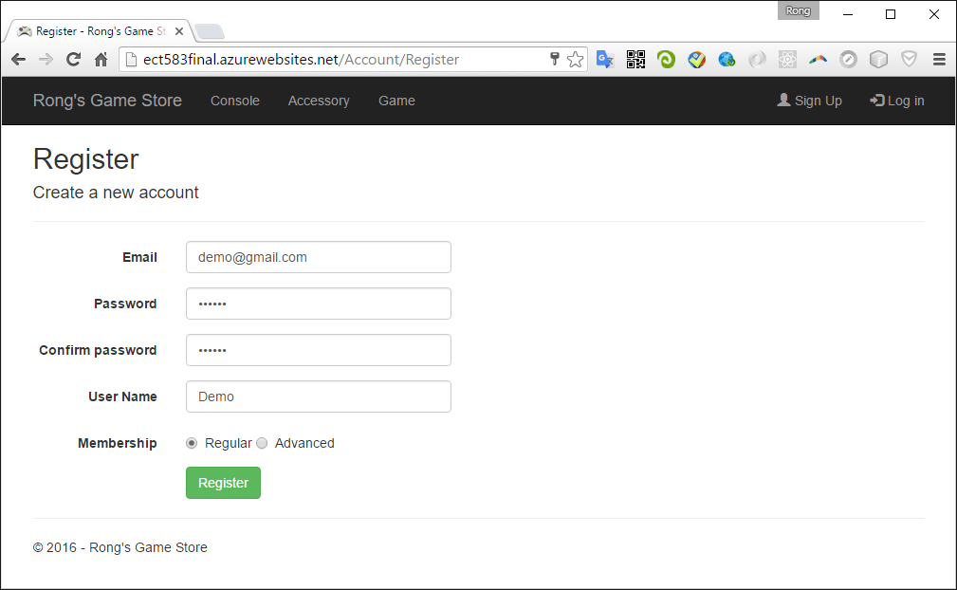

Redirect to Credit Gateway for payment.

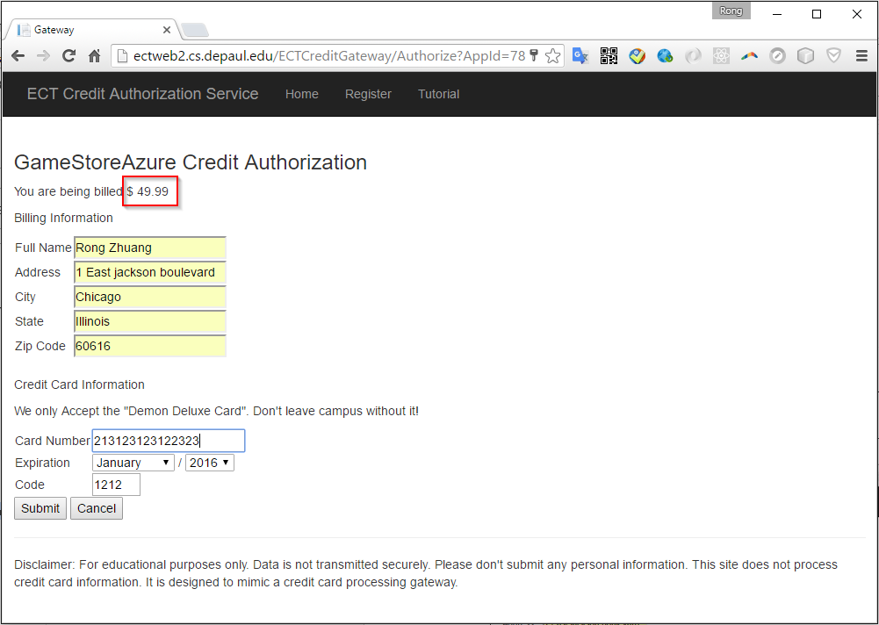

Return url: http://ect583final.azurewebsites.net/Account/ProcessCreditResponse

If the gateway works properly, the new user will finish registration and login automatically.

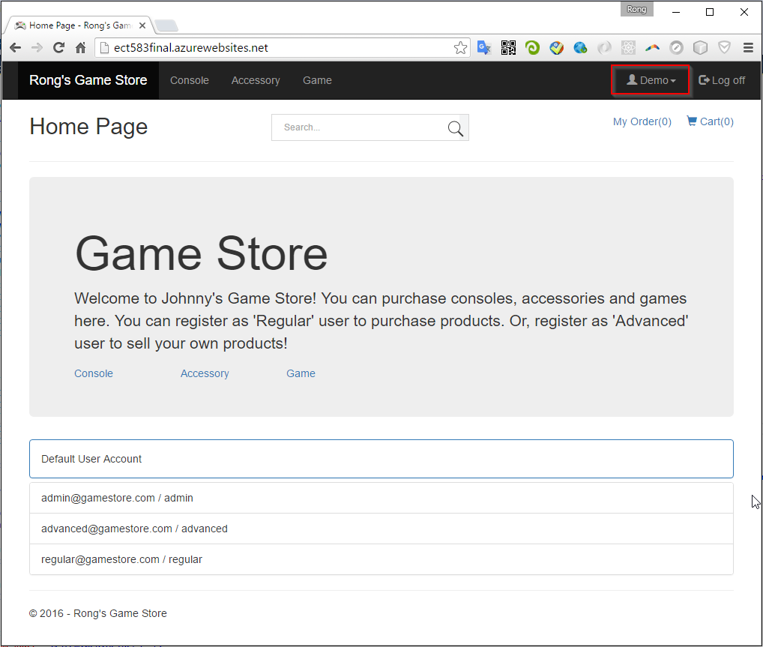

* 1. Login

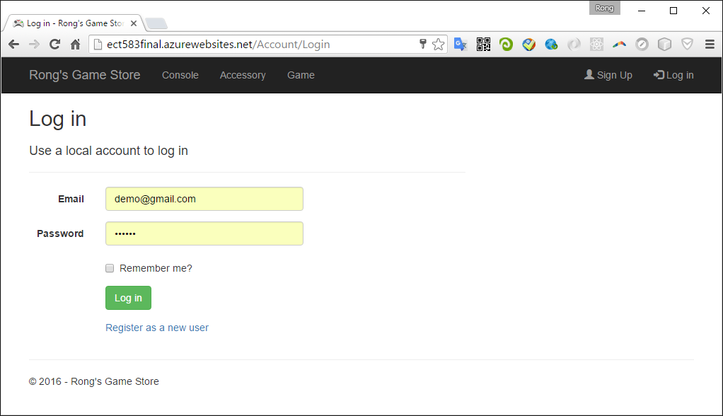

* 1. Profile

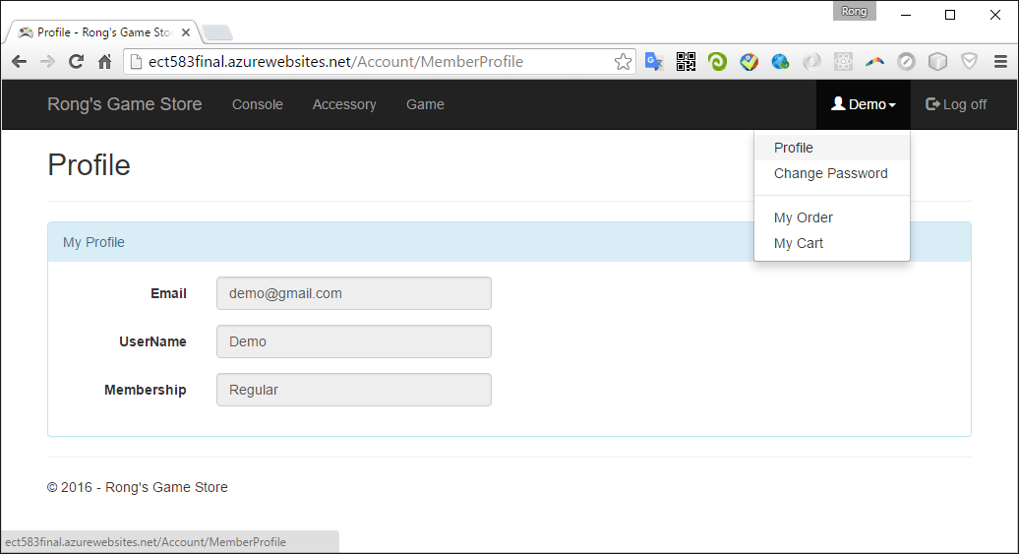

* 1. Change Password

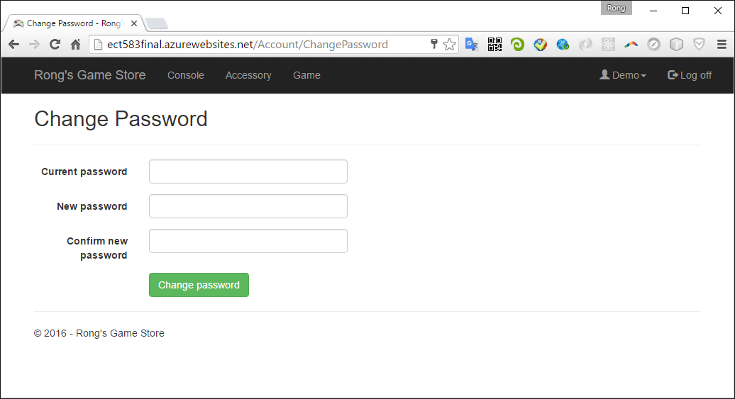

# Role-Based Functions

* All the role based functions are available only for authorized users. You will be redirected to the login page if you try to access the unauthorized pages/functions.
* After successfully login, the buttons at the top right of the webpage are changed. You username will be displayed and you can logout.
  1. Regular User

Regular user can purchase products, add item to cart and place order finally. In the product list page, the original and discounted price are both shown for each product. Click ‘Add to cart’ button to add the current item to your cart.

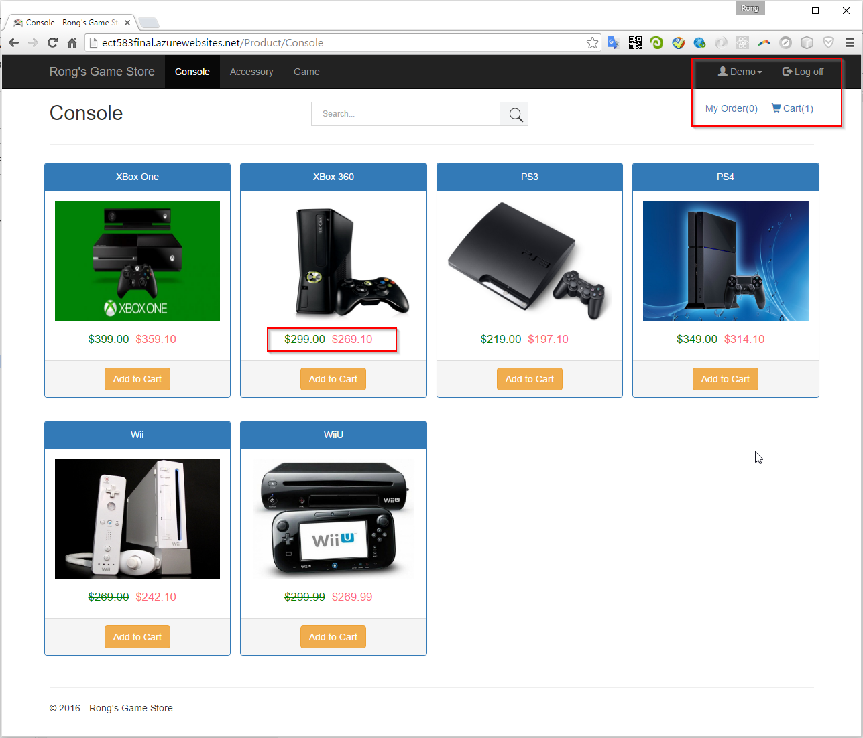

* + 1. Cart

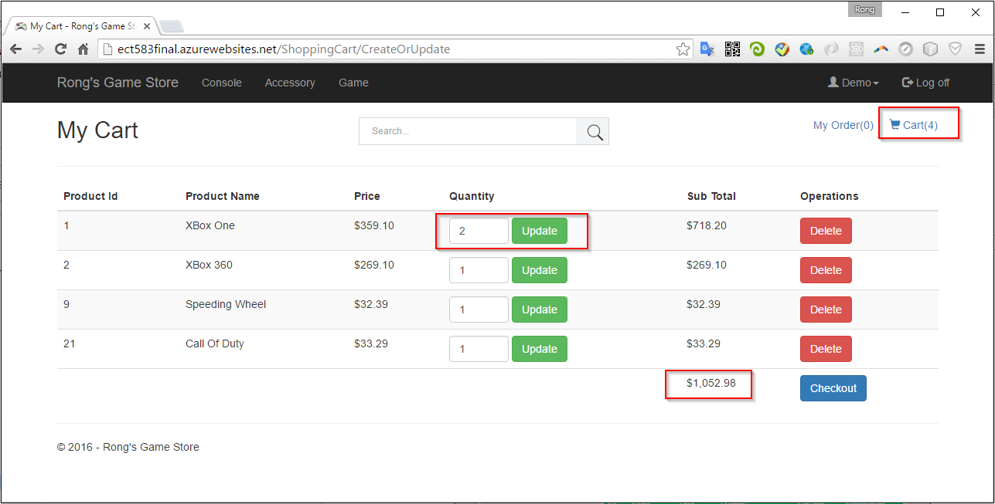

1. You can choose any product(console, accessory or game) added to your cart.
2. If any item added/removed from the cart, ‘Cart(n)’ will be refreshed immediately.
3. In the cart, you can update the quantity.
4. You can also remove the item.
5. The price is the discounted price.
6. The SubTotal shows the amount for each item cost(quantity may be larger than 1).
7. The Total shows the total amount cost of all items in this cart.
   * 1. Checkout
8. Provide the shipping information.

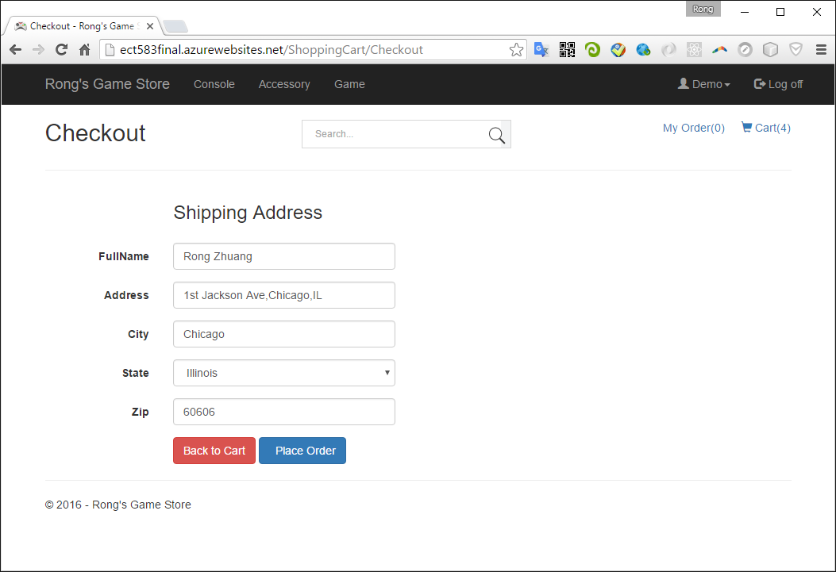

Go to another credit gateway for payment.

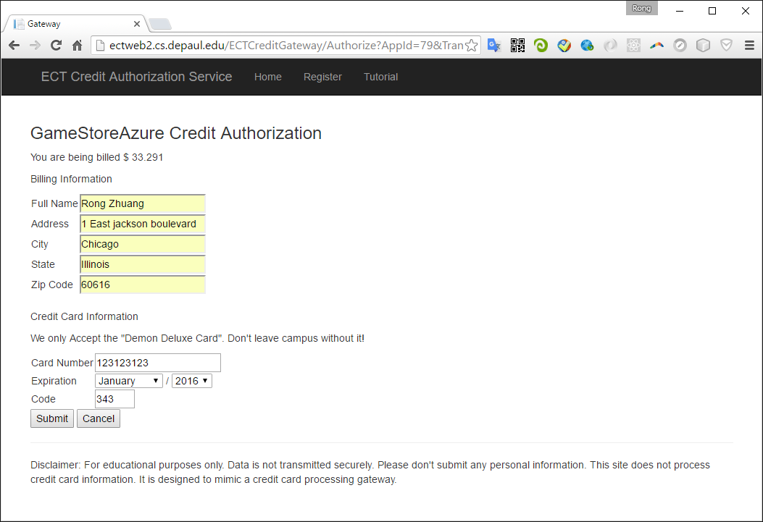

Return URL:http://ect583final.azurewebsites.net/ShoppingCart/ProcessCreditResponse

* + 1. Place Order

1. If successful with the payment, the items in cart are removed. Meanwhile, the order count is incremented by 1.
2. Confirmation Number is generated based on the current time: yyyyMMddHHmmss.
3. The delivery date is 2 weeks after the order date.

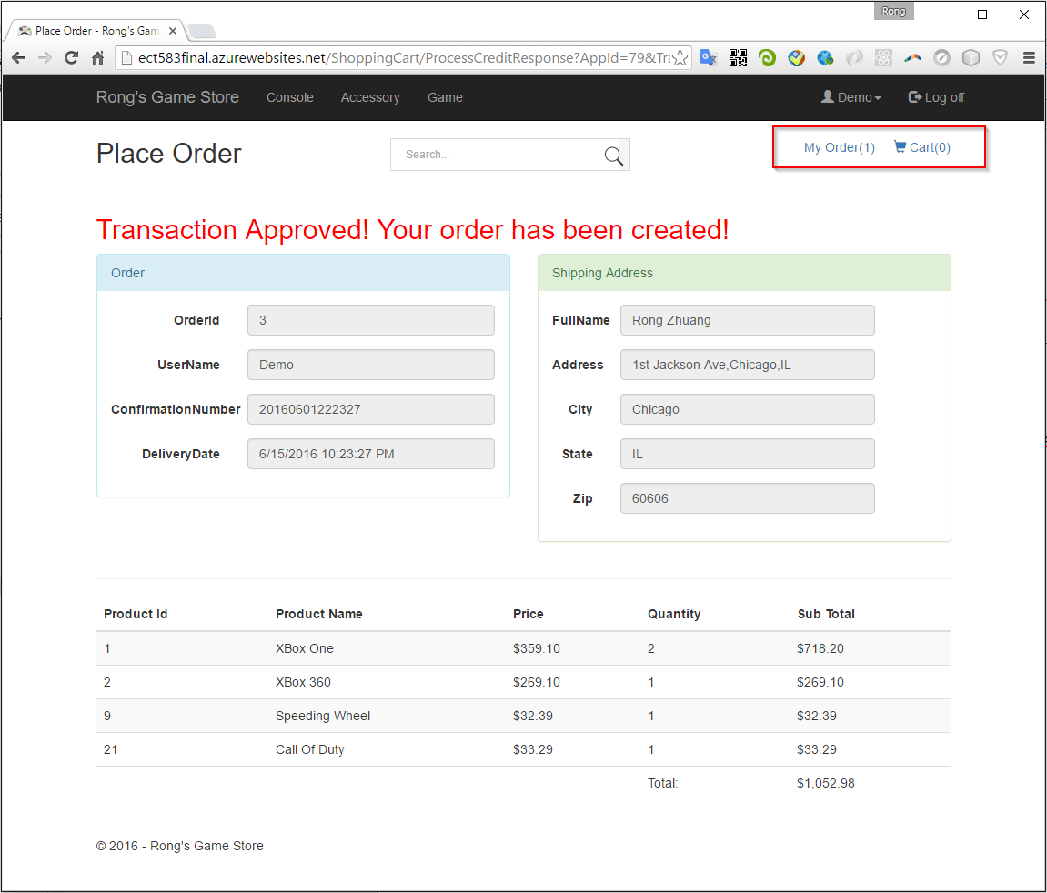

* + 1. My Order

1. Order list with detailed purchased items.
2. You can cancel the order here.
3. If there are multiple orders, all of them will be displayed, with detailed items and quantities.

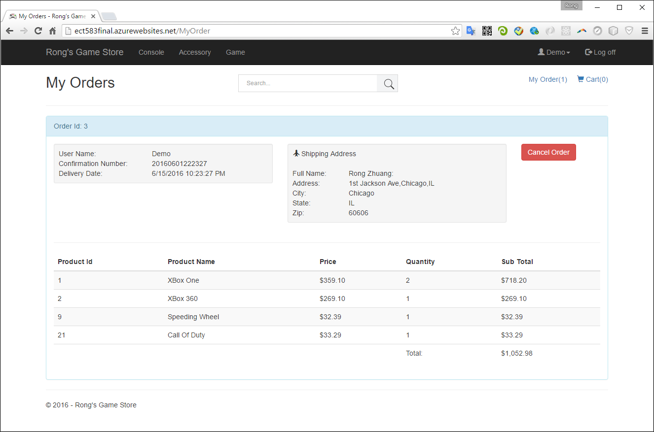

* 1. Advanced User

1. Advanced User has the full functions of Regular User. Besides, Advanced user can create own product and sell to others.
2. Login with the default user ‘advanced@gamestore.com’ and password ‘advanced’.
3. After login, you will see two more different menu options: ‘My Products’ and ‘My Product Orders’.

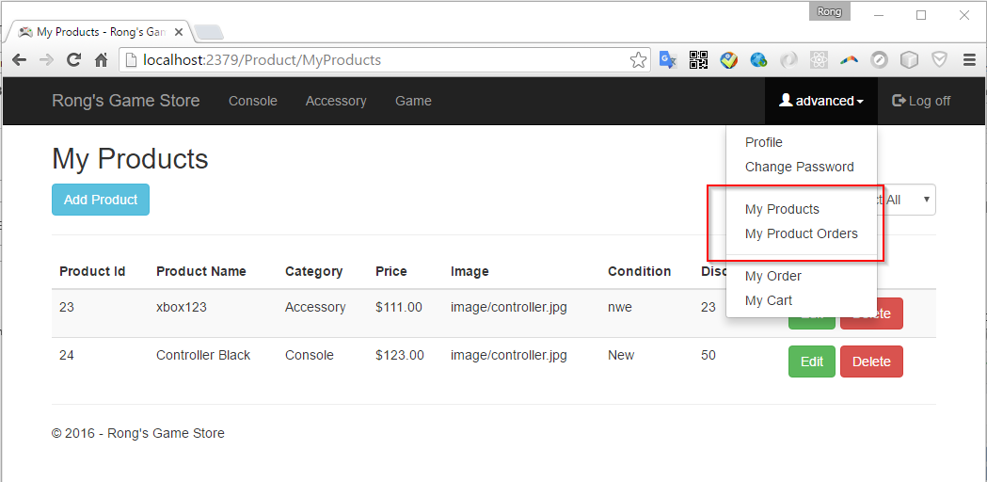

* + 1. My Products

You can create, edit, and delete products for selling.

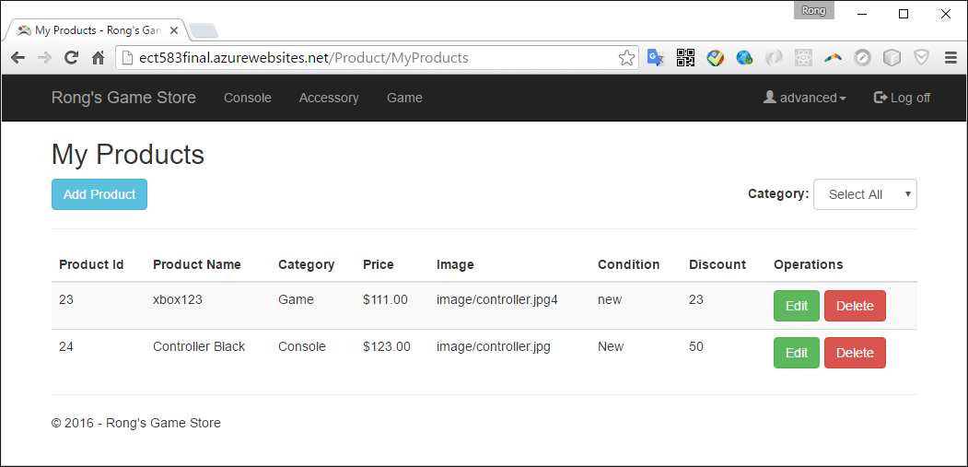

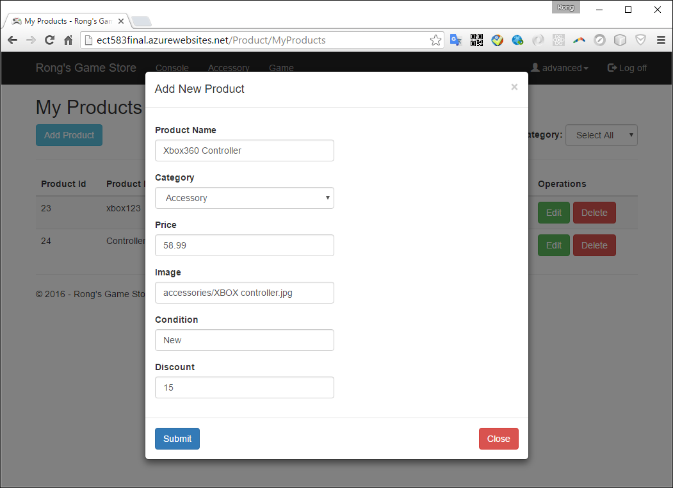

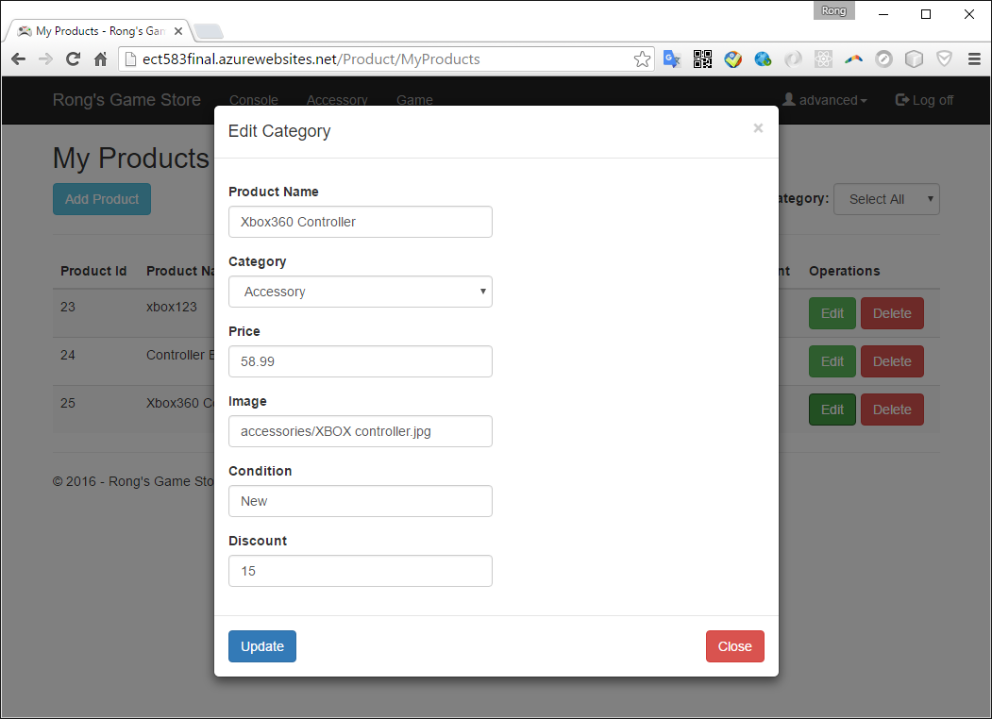

The new product will be displayed in the front page.

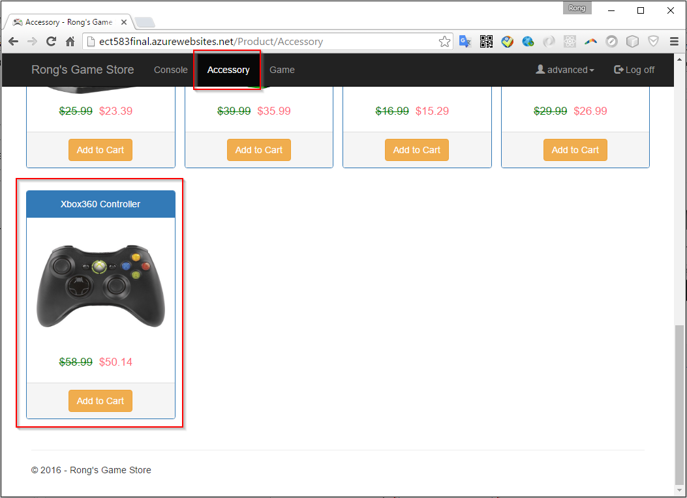

* + 1. My Product Orders

The page shows all your own products and sales orders which contains these products.

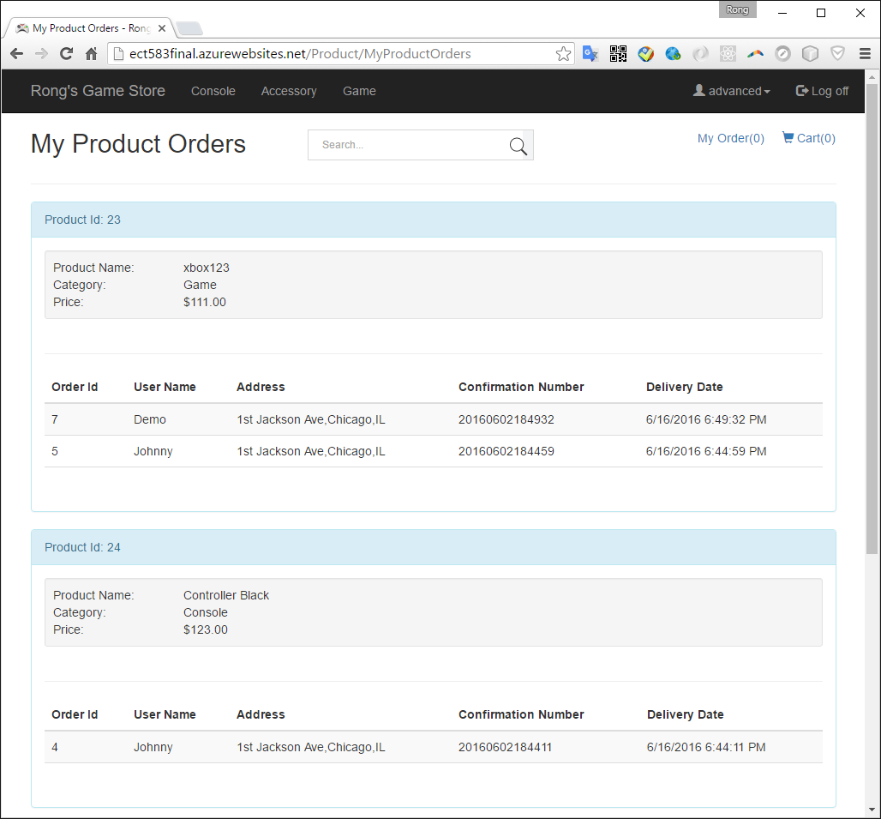

* 1. Admin

1. Admin User has the full functions of Regular User. Besides, Advanced user can create user, role, product, category, cancel order and monitor the application with dashboard.
2. Login with the default user ‘admin@gamestore.com’ and password ‘admin’.
3. After login, you will see more menu options: Dashboard, User, Role, Product, Category and Order.

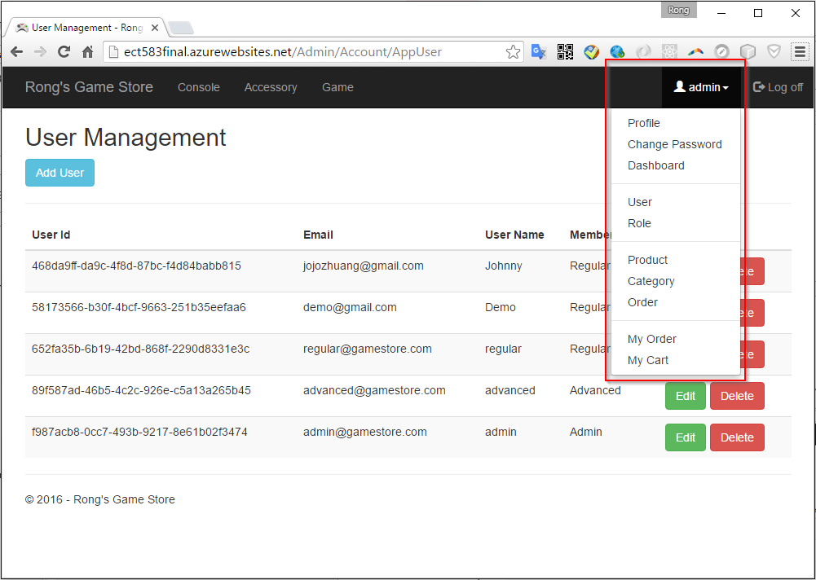

* + 1. Dashboard

You can get the current status overview of the game store. Besides, you can clear the cache.

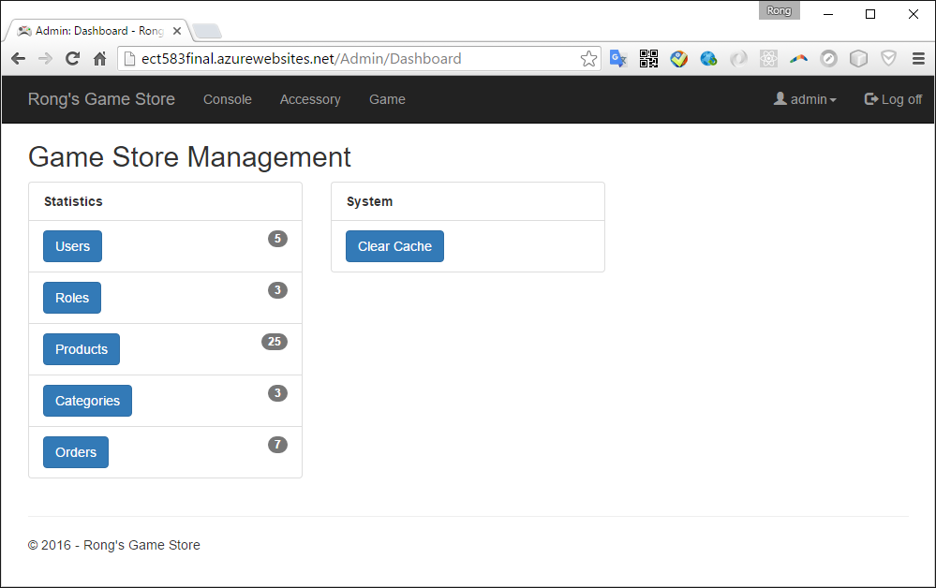

* + 1. User

You can create, edit, and delete users.

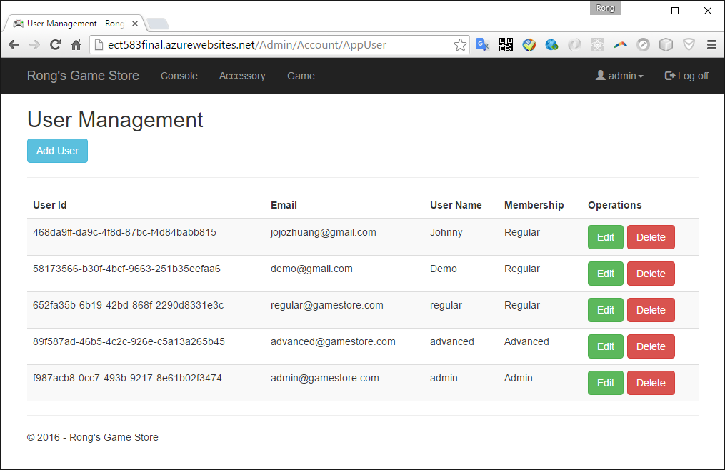

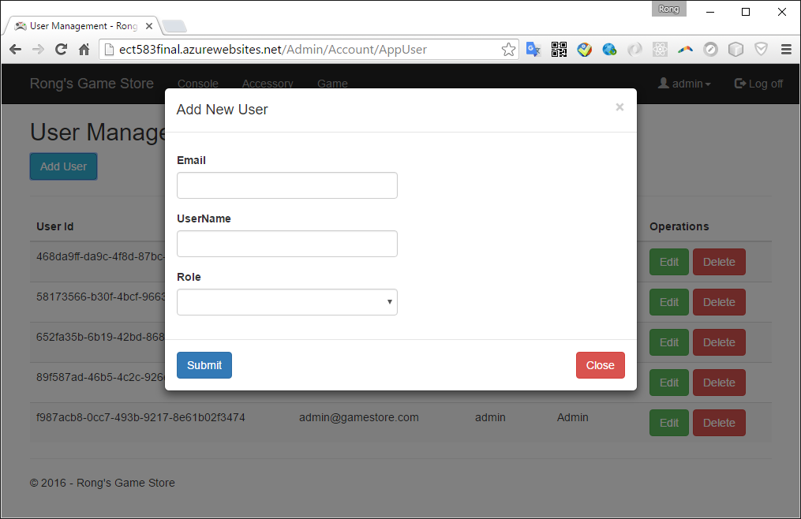

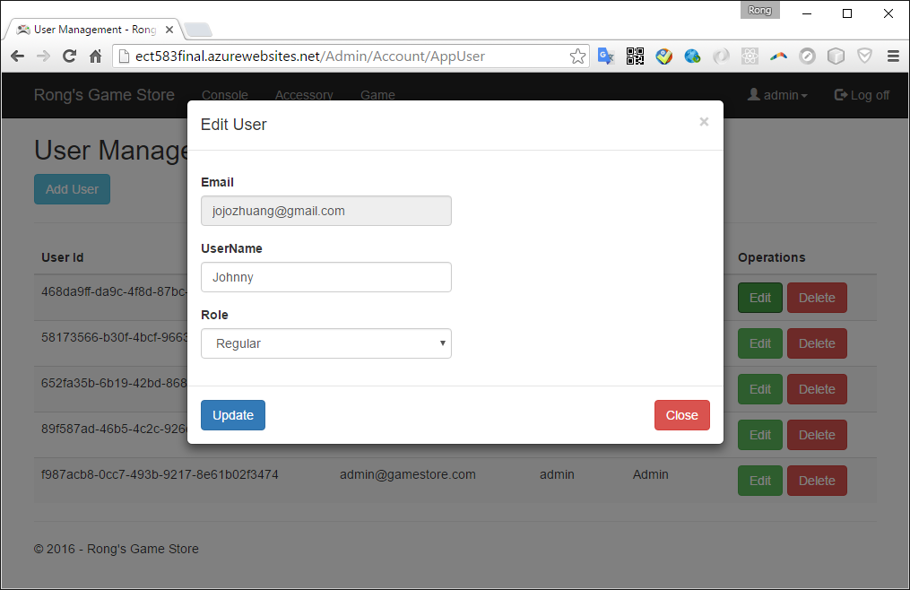

* + 1. Role

You can create, edit, and delete roles.

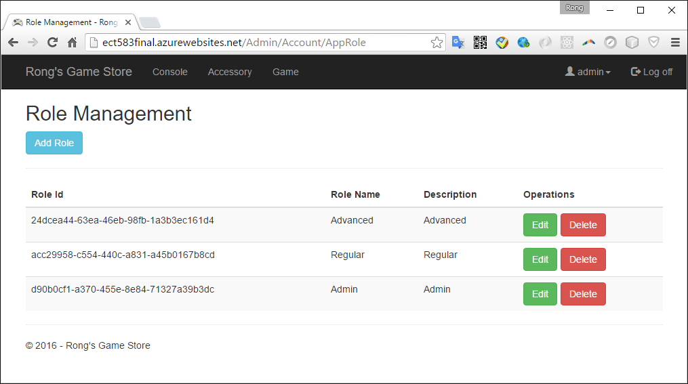

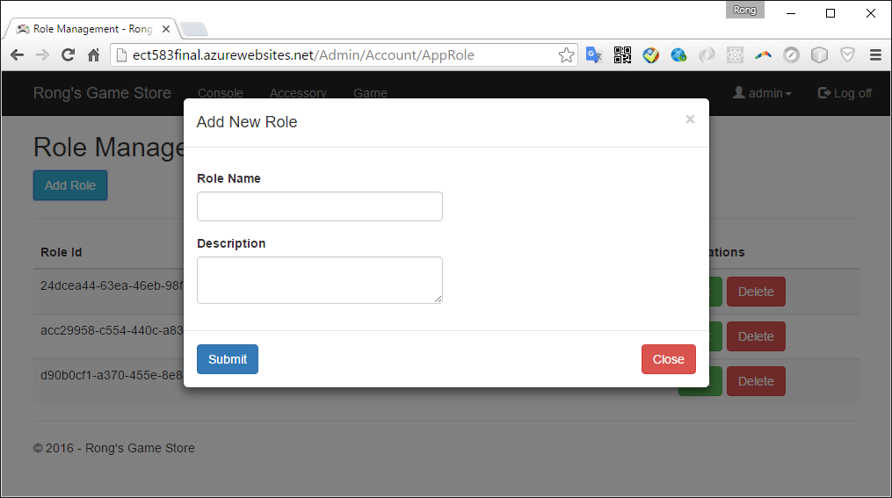

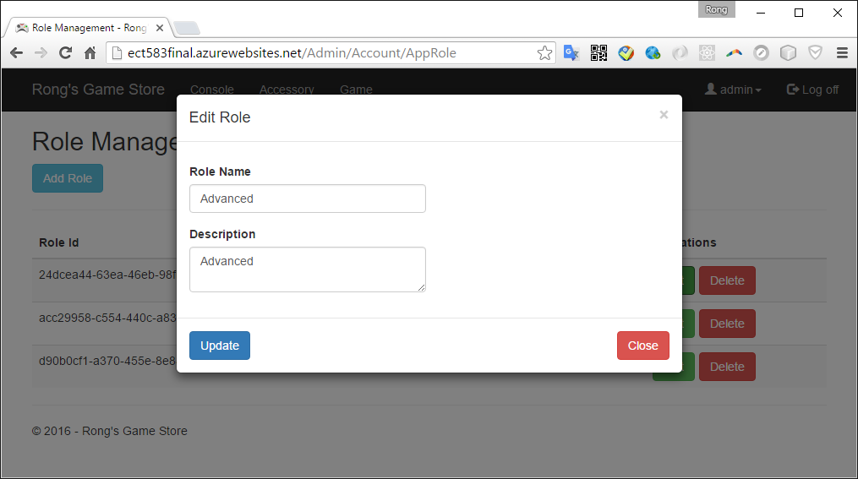

* + 1. Product

You can create, edit, and delete products.

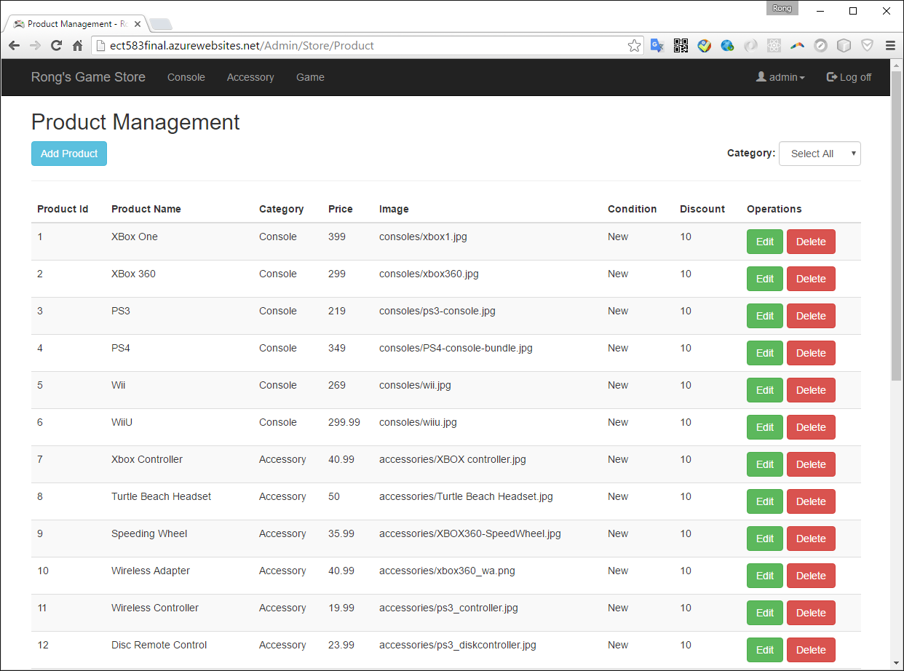

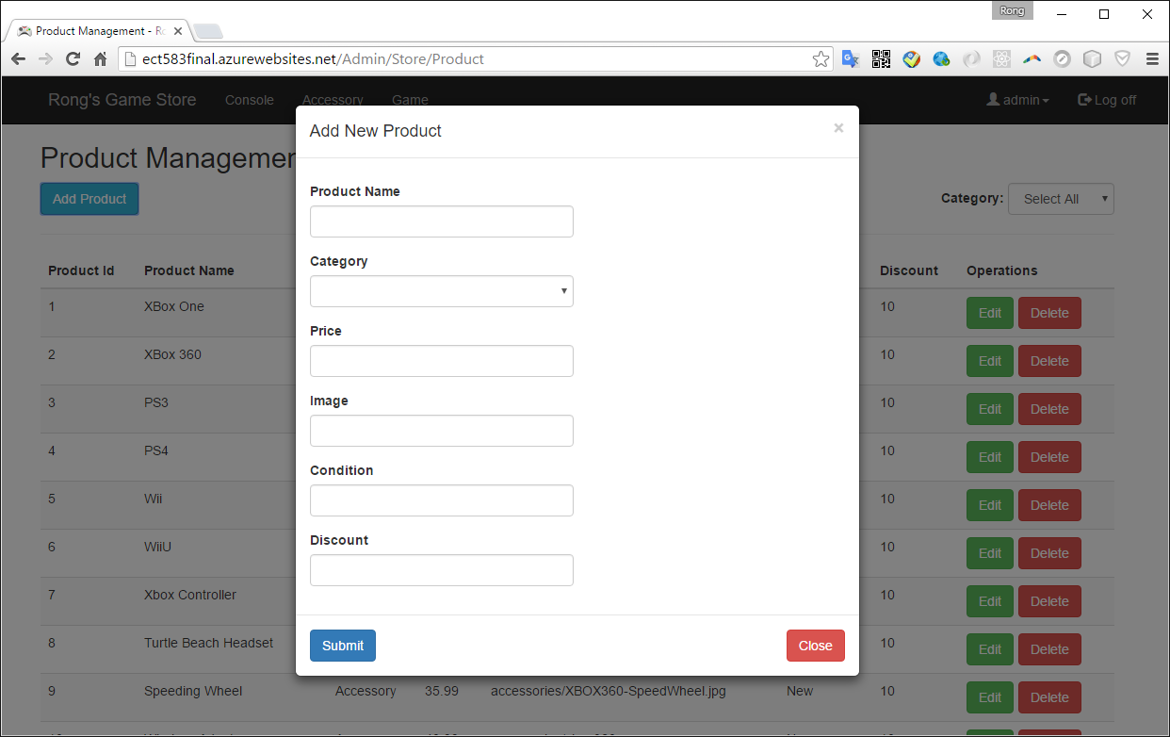

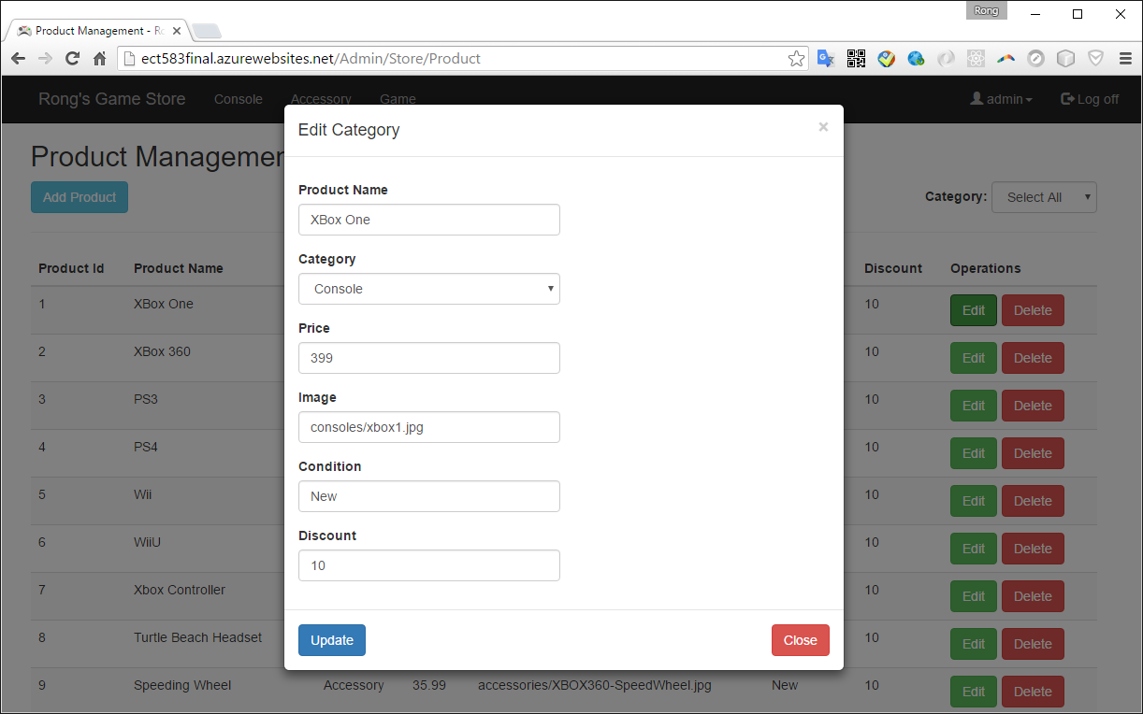

* + 1. Category

You can create, edit, and delete product categories.

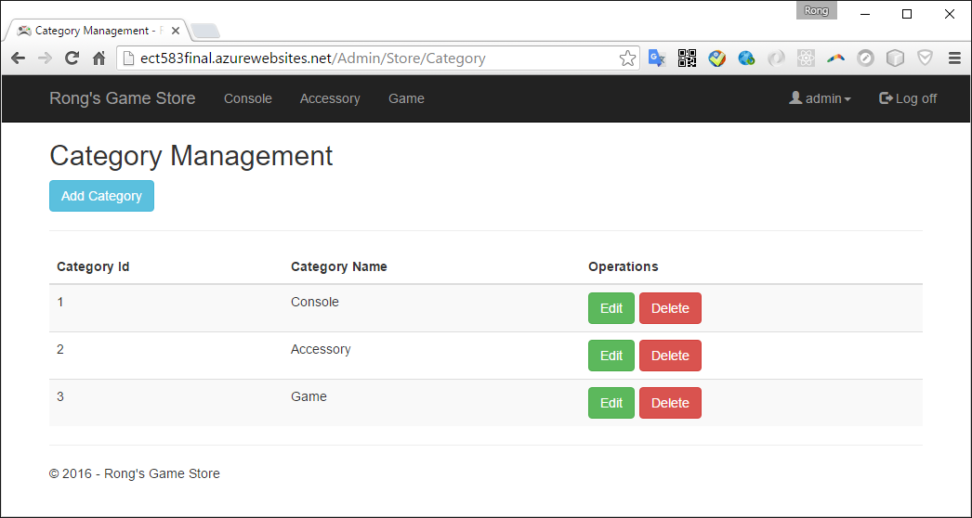

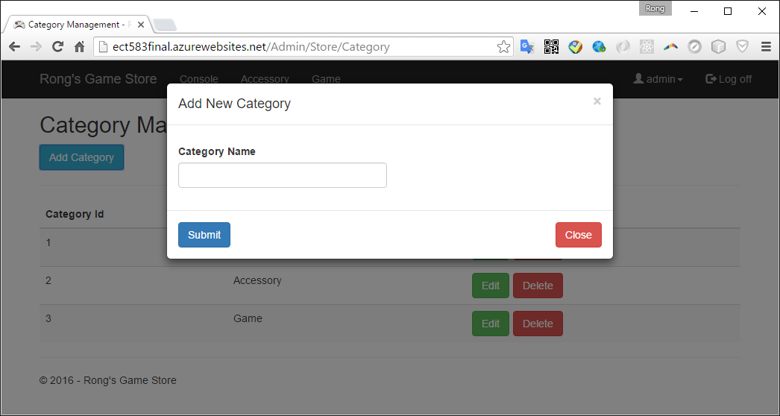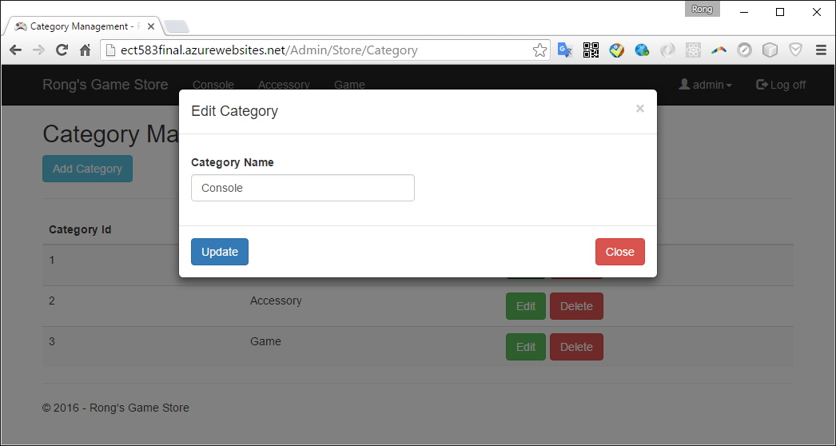

* + 1. Order

You can view and delete order, view detail items of the order.

